

Human–Computer Interaction (HCI) Project Report
Collaborative Group Project Hub

Submitted by:
Muhammad Rehan Mehdi
Registration No: 55189
Department of Computer Science
Riphah International University

Submitted to:
Mr. Muhammad Shabbir
Course Instructor – Human–Computer Interaction (HCI)

Program:
Bachelor of Science in Computer Science (BSCS)

Semester:
5th Semester, Section 1

Institution:
Riphah International University

Date of Submission:
November 7, 2025
Table of Contents
1. Project Description: 5
2. Why This is an Ideal HCI Project: 5
3. Phase 1 – User Research & Problem Definition 5
3.1 Survey Overview 5
3.2 Survey Analysis Summary 6
3.2.1 Participation & Communication 6
3.2.2 Organization & Task Management 6
3.2.3 File Management Issues 6
3.2.4 Satisfaction & Collaboration Challenges 7
3.2.5 Desired Features and Improvements 7
3.2.6 Roles and Responsibilities 7
3.3 Key Insights 8
4. Problem Statement 8
5. Phase 1 – Personas: 8
5.1 Persona 1: Muhammad Rehan – The Collaborative Student 8
5.1.1 Persona Description: 8
5.2 Persona 2: Ali Raza – The Developer/Designer 9
5.2.1 Persona Description: 9
6. Phase 2 – Sketches: 10
6.1 Phase 2: Ideation & Conceptual Design 10
6.1.1 Activities include: 10
6.2 Sketch 1 – Team Task Dashboard 11
6.2.1 Brief Description: 11
6.4 Sketch 3 – Progress Tracking Interface 13
6.4.1 Brief Description 13
6.5 Sketch 4 – File Sharing/Preview Interface 14
6.5.1 Brief Description 15
7. Phase 3: Low-Fidelity Prototyping 16
7.1 Activities include: 16
7.2 Low-Fidelity Prototype Overview 16
7.3 GitHub Repository – Low-Fidelity Prototype: 17
7.3.1 User Flow Diagram for Low-Fidelity Prototype 17
8. Phase 4 – Usability Study (Low-Fidelity Wireframe Evaluation) 18
8.1 Objective 18
8.2 Participants 18
8.3 Methodology 19
8.4 Findings 19
8.4.1 Key Strengths 19
8.4.2 Areas for Improvement 19
8.5 Conclusion and Recommendations 20
9. Phase 5 — Iterative Design & High-Fidelity Prototyping 20
9.1 Purpose and Scope 20
9.2 Prototype Overview 21
9.3 Key Features & Screens 21
9.3.1 Project Dashboard 21
9.3.2 Task Management 22
9.3.3 File Sharing 23
9.3.4 Notifications Center 24
9.3.5 Chat & AI Assistant 24
9.3.6 Profile & Settings 25
9.3.7 Timeline / Milestones 25
9.3.8 Invitations Module 26
9.4 Technical Implementation 28
9.5 Design System & Visual Identity 28
9.6 Iterative Refinements in Phase 5 29
9.7 Limitations 29
9.8 How to Run the Prototype 29
9.9 GitHub Repository Link 29
7.9.1 Description: 29
9.10 Conclusion 30
10. Phase 6: Summative Evaluation & Final Presentation 30
10.1 Goal 30
10.2 Evaluation Objectives 30
10.3 Comparative Evaluation 31
10.3.1 Purpose of Comparison 31
10.3.2 Comparative Tools Overview 31
10.4 Evaluation Criteria and Results 32
10.4.1 Task Management & Project Tracking 32
11.4.2 Communication & Collaboration 32
11.4.3 File Sharing & Version Control 33
11.4.4 Notification System 33
11.4.5 Ease of Use & Learning Curve 33
11.4.6 Accessibility & Customization 34
11.4.7 Academic Context Suitability 34
11.5 Strengths and Weaknesses Summary 35
11.5.1 Collaborative Group Project Hub (CGPH) 35
11.5.2 Notion 35
11.5.3 Slack 36
11.5.2.1 Overall Analysis 36
12. Conclusion 36

1. Project Description:
The Collaborative Group Project Hub is a web-based platform designed to enhance teamwork among university students by integrating task management, file sharing, communication, and project tracking into a single interface. Currently, students rely on multiple disconnected tools such as Google Drive, WhatsApp, and Trello, which leads to confusion, version control issues, and missed deadlines.
This project aims to design an intuitive, accessible, and visually clear interface that simplifies collaboration and reduces cognitive load. The design process will follow User-Centered Design (UCD) principles through stages of user research, ideation, prototyping, and usability testing. The final outcome will be a high-fidelity interactive prototype created using Figma AI and exported to React TypeScript for presentation.

2. Why This is an Ideal HCI Project:
This project embodies the essence of Human–Computer Interaction (HCI) by focusing on user needs, interface usability, and iterative design rather than full system functionality. It addresses a real-world, moderately complex challenge within the area of Computer-Supported Cooperative Work (CSCW) — improving digital collaboration among students.
Key HCI aspects include:
- Information architecture: Clear organization of tasks, files, and communication.
- Interaction design: Intuitive workflows for creating, assigning, and tracking project activities.
- Usability and accessibility: Interfaces that are visually consistent, inclusive, and easy to learn.
Overall, this project demonstrates the full HCI lifecycle — from understanding user problems to designing and refining an effective interactive solution.

3. Phase 1 – User Research & Problem Definition

3.1 Survey Overview
A Google Form titled “Survey on Student Collaboration Challenges in Group Projects” was distributed among university students to explore how they currently collaborate on academic projects, the tools they utilize, and the challenges they face in managing group tasks effectively.
The objective of this survey was to identify pain points in existing collaboration practices and gather insights to inform the design of an improved, user-centered solution.
Survey Link: Google Form – Survey on Student Collaboration Challenges in Group Projects

3.2 Survey Analysis Summary

3.2.1 Participation & Communication
- Most respondents reported participating in multiple group projects per semester.
- WhatsApp emerged as the dominant platform for team communication and coordination.
- For file sharing, students commonly use WhatsApp or Email attachments, while a smaller portion utilizes Google Drive.

3.2.2 Organization & Task Management
- A majority of students indicated that they do not use any formal system for task management or progress tracking.
- Commonly reported methods include:
  - “Verbal updates or chat messages.”
  - Occasional use of shared documents or spreadsheets.
  - “We don’t track progress formally.”
- This lack of structure often leads to confusion about task responsibilities, missed deadlines, and duplication of work.

3.2.3 File Management Issues
- Many participants experienced version control problems and difficulty identifying the latest versions of files.
- Sharing files through WhatsApp or Email frequently resulted in disorganized file storage and data inconsistencies.

3.2.4 Satisfaction & Collaboration Challenges
- The average satisfaction level with current project management methods was reported as 2–3 out of 5, indicating widespread dissatisfaction.
- Major challenges identified include:
  - Unequal participation
  - Poor communication
  - Lack of clear task assignment
  - Absence of a centralized workspace
- Several respondents selected “All of the above” when asked about their primary collaboration difficulties, reinforcing the need for a unified solution.

3.2.5 Desired Features and Improvements
- Respondents expressed a strong interest in a single integrated web platform offering:
  - Task assignment and progress tracking
  - Real-time communication
  - File sharing with version control
  - Role-based access and visibility
- Some participants also suggested the integration of AI-assisted tools for smart task allocation and progress analysis, while others emphasized the importance of simplicity and intuitive design.

3.2.6 Roles and Responsibilities
- Students reported assuming diverse roles such as developer, designer, presenter, or researcher within their groups.
- This highlights the need for customized interfaces and permissions tailored to each user’s role within a project.

3.3 Key Insights
- Students predominantly rely on informal tools like WhatsApp and Email that are not designed for structured project collaboration.
- This reliance results in poor organization, unclear accountability, and inefficient coordination among team members.
- There is a clear opportunity to design an academic-focused digital collaboration platform that integrates communication, task management, and file control in one place.

4. Problem Statement
University students engaged in academic group projects face persistent challenges in organizing tasks, tracking progress, and managing shared files due to their reliance on informal communication tools such as WhatsApp and Email. These tools lack the structure, transparency, and coordination features required for effective teamwork. Therefore, there is a need for a centralized, user-friendly digital platform specifically designed to support academic collaboration by integrating task management, real-time communication, and file version control—ultimately enhancing productivity, accountability, and teamwork efficiency.

5. Phase 1 – Personas:

5.1 Persona 1: Muhammad Rehan – The Collaborative Student
To better understand the target users and their needs, we created a persona representing a typical student who would benefit from our proposed solution. This persona helps guide design decisions by highlighting user goals, behaviors, and pain points.

5.1.1 Persona Description:
Muhammad Rehan is an undergraduate Computer Science student in his final year. He often takes the lead role in group projects, ensuring tasks are clearly assigned and deadlines are met. He relies heavily on digital tools such as Google Docs, Sheets, and WhatsApp for communication, coordination, and submission.
Figure 1: Muhammad Rehan – Final-year student persona providing a graphical representation of Persona 1.
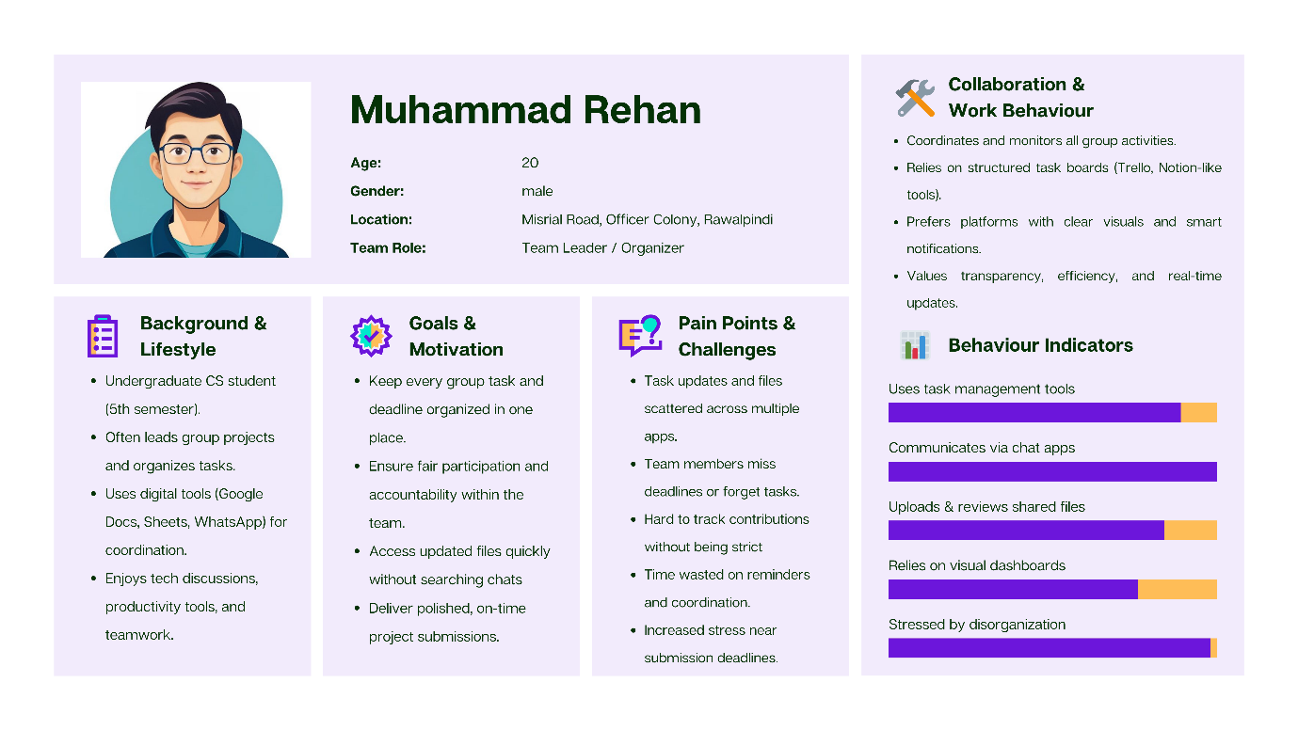
Figure 1: Muhammad Rehan – Final-year student persona
Canva Link – Persona 1:
https://www.canva.com/design/DAG4GhAUopM/cDQovuyr9pQ-jbMYBGZxTA/edit?utm_content=DAG4GhAUopM&utm_campaign=designshare&utm_medium=link2&utm_source=sharebutton

5.2 Persona 2: Ali Raza – The Developer/Designer
To ensure our design meets the needs of users involved in development and design tasks, we created a persona representing a typical developer/designer. This persona highlights their goals, behaviors, and pain points.
5.2.1 Persona Description:
Ali Raza is an undergraduate Computer Science student who often takes on the role of developer and designer in group projects. He is highly skilled with coding, UI/UX tools, and design software, and relies on platforms like Visual Studio Code, Figma, and GitHub for development and collaboration.
Figure 2: Ali Raza – Persona representing a developer/designer user providing a graphical representation of Persona 2.
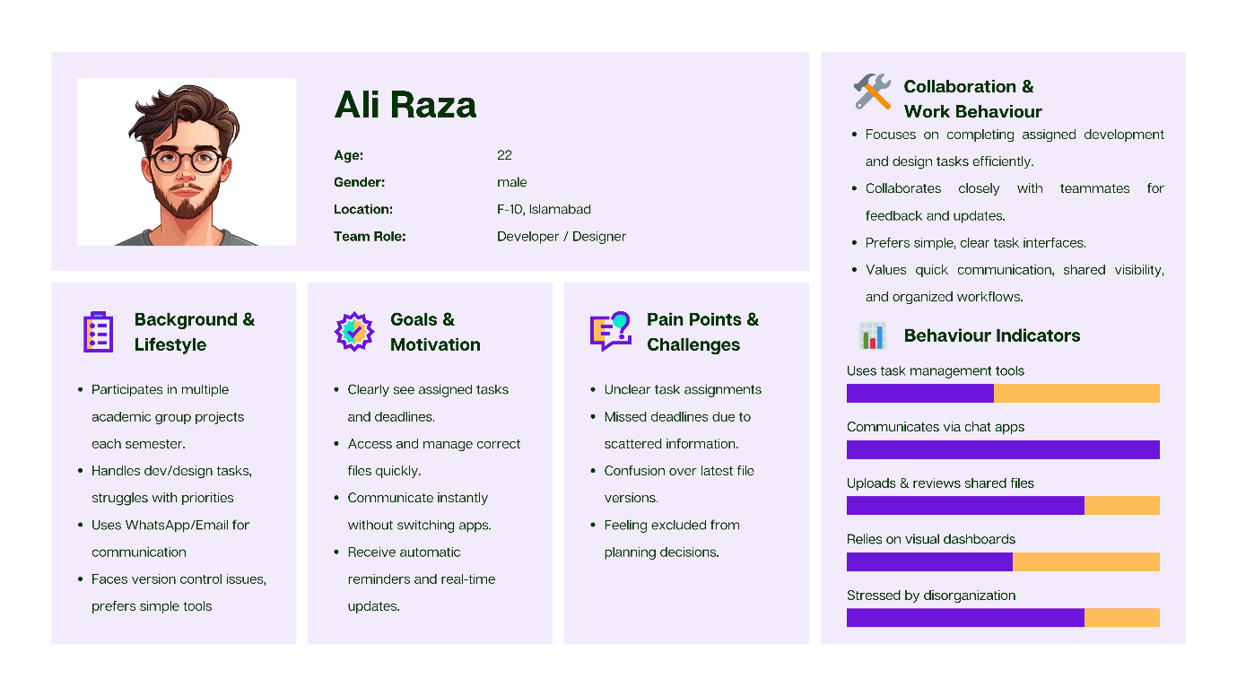
Figure 2: Ali Raza – Persona representing a developer/designer user

Canva Link – Persona 1:
https://www.canva.com/design/DAG4G1FOBUI/FNYTt35mNSrUsKGUItkK8A/edit?utm_content=DAG4G1FOBUI&utm_campaign=designshare&utm_medium=link2&utm_source=sharebutton

6. Phase 2 – Sketches:

6.1 Phase 2: Ideation & Conceptual Design
In this phase, the focus is on generating ideas and exploring potential solutions based on the insights gathered during user research. The goal is to translate user needs, pain points, and requirements into conceptual designs that can guide prototype development.

6.1.1 Activities include:
- Brainstorming: Generating a wide range of ideas to address the identified problems.
- Sketching & Conceptualization: Creating low-fidelity sketches or diagrams to visualize different approaches.
- Concept Evaluation: Reviewing and selecting ideas based on feasibility, user needs, and project goals.
- Defining Core Features & User Flows: Outlining the essential functions and how users will interact with them.
The outputs of this phase provide a foundation for the subsequent prototyping phase, ensuring that designs are user-centered and aligned with the project objectives.

6.2 Sketch 1 – Team Task Dashboard
To begin visualizing our concepts, we created a series of sketches representing key user interfaces. Sketch 1 – Team Task Dashboard illustrates how users can view, manage, and track their group project tasks efficiently, providing a clear overview of responsibilities and deadlines.
6.2.1 Brief Description:
This dashboard provides a clear overview of all project tasks, ongoing projects, and team activities. It helps managers or team leads quickly monitor progress, prioritize tasks, and stay updated on notifications, reducing confusion and improving coordination.
Figure 3: Sketch 1 – Team Task Dashboard provides a graphical view of the user interface for managing and tracking team tasks.
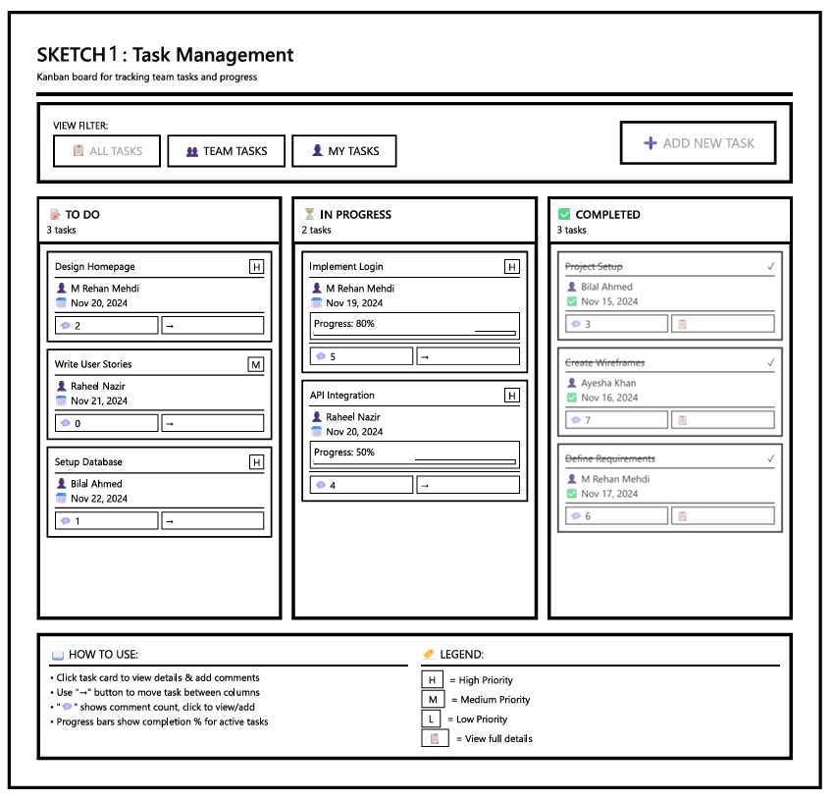
Figure 3: Sketch 1 – Team Task Dashboard

Canva Link – Sketch 01:
https://www.canva.com/design/DAG5sZxTWVU/bWH-az06hsoBG0YfaPx-UQ/edit?utm_content=DAG5sZxTWVU&utm_campaign=designshare&utm_medium=link2&utm_source=sharebutton

6.3 Sketch 2 – Collaboration & Communication Screen
To further explore user interactions, Sketch 2 – Collaboration & Communication Screen demonstrates how team members can communicate, share updates, and collaborate seamlessly within the platform. This interface emphasizes real-time interaction and easy access to project discussions.
6.3.1 Brief Description:
This interface organizes group chat, file sharing, notes, and active members in one place. It addresses the problem of dispersed communication and scattered resources, making it easier for team members to share updates, collaborate, and track discussions in real time.
Figure 4: Sketch 2 – Collaboration & Communication Screen provides a graphical view of how users interact, communicate, and collaborate within the project environment.

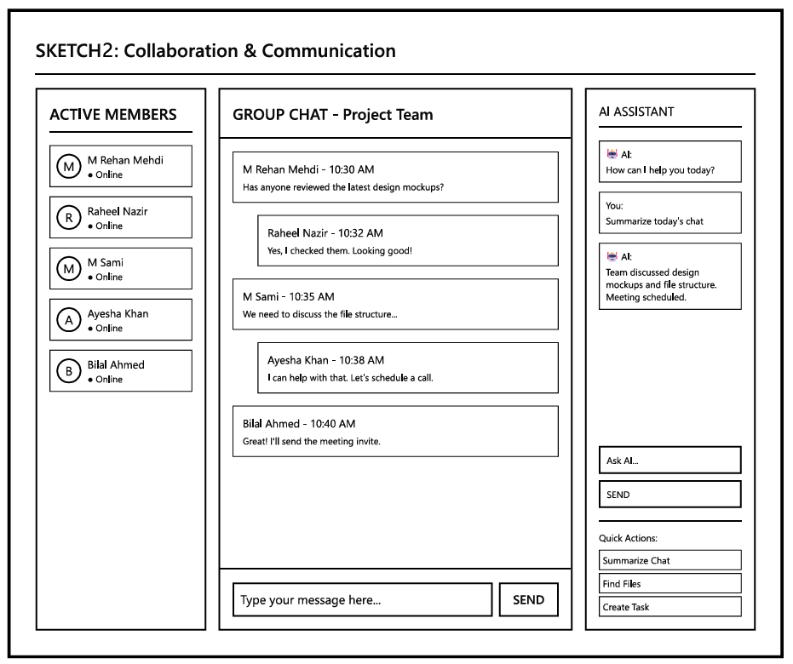
Figure 4: Sketch 2 – Collaboration & Communication Screen

Canva Link – Sketch 02:
https://www.canva.com/design/DAG5sbWuMlU/So7x36piUCQv5tGtKrYZtA/edit?utm_content=DAG5sbWuMlU&utm_campaign=designshare&utm_medium=link2&utm_source=sharebutton

6.4 Sketch 3 – Progress Tracking Interface
To visualize project monitoring, Sketch 3 – Progress Tracking Interface illustrates how users can track the status of tasks, monitor milestones, and view overall project progress at a glance. This interface ensures transparency and helps teams stay on schedule.
6.4.1 Brief Description
This layout visualizes individual and team progress, milestones, and weekly summaries. It helps increase accountability and transparency by showing what has been completed, what is pending, and overall project health, allowing the team to identify bottlenecks early.
Figure 5: Sketch 3 – Progress Tracking Interface showing task status and project progress visually.
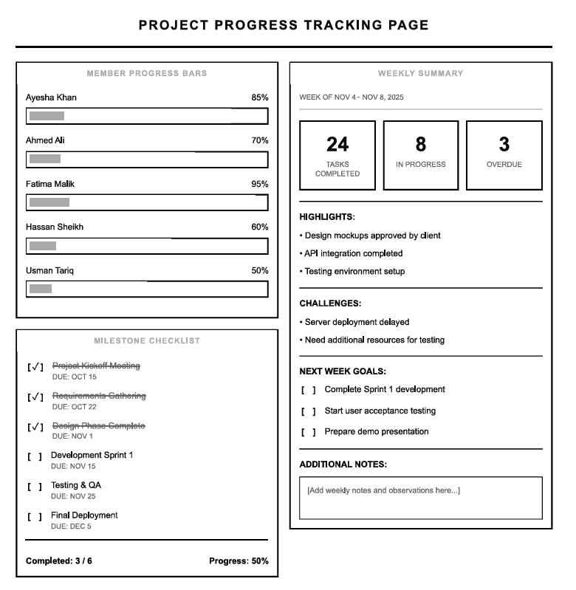
Figure 5: Sketch 3 – Progress Tracking Interface
Canva Link – Sketch 03:
https://www.canva.com/design/DAG5sZzRpm8/P73EVYCl2rDJuc3IYctu3Q/edit?utm_content=DAG5sZzRpm8&utm_campaign=designshare&utm_medium=link2&utm_source=sharebutton

6.5 Sketch 4 – File Sharing/Preview Interface
Sketch 4 – File Sharing/Preview Interface showcases a user-friendly space where team members can efficiently manage project documents. This interface allows users to search for files, filter them by categories such as .docx, .ppt, .pdf, .xlsx, and quickly locate the content they need.
It also supports easy file uploading, ensuring that teams can continuously add new resources and share important updates.
Each file displays its latest available versions (v1, v2, v3…), giving users clarity on document history and preventing confusion between outdated and updated editions. Additionally, users can preview, download, or delete files directly from the interface, enabling smooth and transparent file management throughout the project.

6.5.1 Brief Description
This design helps teams maintain organized documentation, improve collaboration, and ensure that every member always has access to the most up-to-date files.
As shown in Figure 6: File Sharing/Preview Interface, users can search, preview, and manage files.
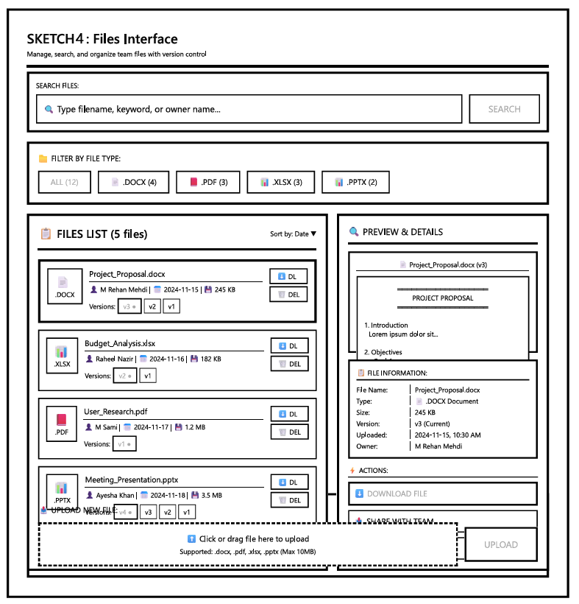
Figure 6: File Sharing/Preview Interface

Canva Link – Sketch 04:
https://www.canva.com/design/DAG5sUQ5nhM/hyB5PdMqGVm8cWfXVdsfiw/edit?utm_content=DAG5sUQ5nhM&utm_campaign=designshare&utm_medium=link2&utm_source=sharebutton

7. Phase 3: Low-Fidelity Prototyping
In this phase, the focus shifts from conceptual design to creating tangible representations of the proposed solutions. Low-fidelity prototypes allow designers and users to quickly explore and test core functionalities, layouts, and workflows without investing heavily in detailed visuals or backend functionality.

7.1 Activities include:
- Paper Prototyping: Hand-drawn sketches of interfaces to visualize user interactions.
- Digital Wireframes: Basic digital mockups showing structure, content placement, and navigation flow.
- User Flow Testing: Ensuring that users can easily perform key tasks and navigate between screens.
- Feedback & Iteration: Gathering early feedback from users to refine and improve the design before high-fidelity prototyping.
The outputs of this phase provide a practical foundation for building more detailed, interactive prototypes in the next phase, ensuring that designs are user-centered and aligned with project goals.

7.2 Low-Fidelity Prototype Overview
The low-fidelity prototype of the Collaborative Group Project Hub was developed using React and TypeScript to demonstrate the structural flow and core functionality of the group project management system. This prototype focuses on layout clarity, logical navigation, and the visibility of key features, while intentionally omitting detailed visual design or stylistic enhancements.
The prototype features clickable navigation elements, enabling users to explore the intended workflow across the following screens:
- Dashboard: Provides an overview of projects, tasks, deadlines, active members, and recent activity.
- Projects: Displays ongoing projects through project cards and detailed project information.
- Task List: Organizes tasks into To-Do, In Progress, and Completed categories, including assignments and due dates.
- Team Members: Shows active members, their roles, project assignments, and current tasks.
- Chat / Messaging: Facilitates team communication and collaboration on specific projects.
- Settings: Allows management of profile information, notification preferences, and passwords.
- Login / Logout: Ensures secure access and session termination.
This low-fidelity prototype allows evaluators to experience the core user flow, assess structural design, interaction flow, and usability, and provide feedback before progressing to a high-fidelity prototype.
7.3 GitHub Repository – Low-Fidelity Prototype:
Git Link: https://github.com/MRehanMehdi/collaboration-hub-lowfi-prototype

7.3.1 User Flow Diagram for Low-Fidelity Prototype
The user flow diagram summarizes navigation and key actions across the low-fidelity prototype screens, providing a clear view of the system’s workflow and user interactions.
Figure 7: User flow diagram of the low-fidelity prototype showing navigation and key interactions in the low-fidelity prototype.
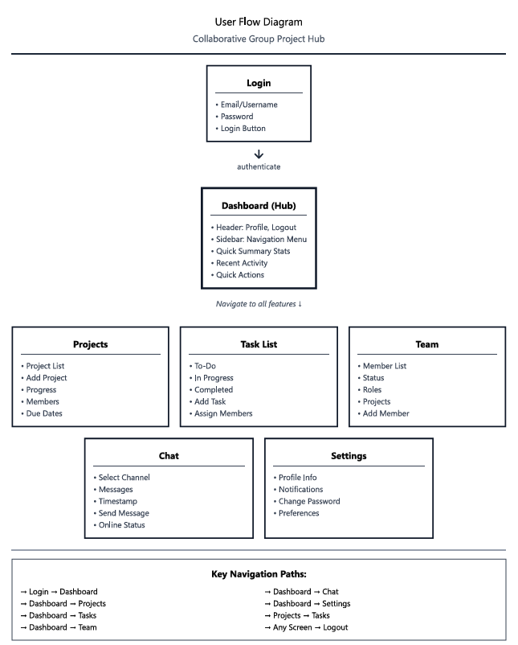
Figure 7: User flow diagram of the low-fidelity prototype

8. Phase 4 – Usability Study (Low-Fidelity Wireframe Evaluation)

8.1 Objective
The primary goal of this phase was to evaluate the usability and functional clarity of the low-fidelity wireframe developed in Phase 3. The study focused on determining whether users could easily understand the structure, navigation flow, and placement of key features before progressing to high-fidelity prototyping.

8.2 Participants
Five university students who regularly collaborate on semester-long group projects participated in the evaluation.
The sample included a Team Leader, Developers, Designer, and Researcher, ensuring diverse perspectives covering management, technical, and design viewpoints.
Each participant performed realistic academic collaboration tasks aligned with their current coursework.

8.3 Methodology
Participants were asked to complete representative tasks using the static wireframe screens, including viewing projects, exploring team progress, accessing communication and settings options, and locating task information.
Observations focused on navigation flow, clarity of labeling, task understanding, and interface organization.
Feedback was collected through short interviews and satisfaction ratings on a 5-point scale.

8.4 Findings
Overall, participants responded positively to the wireframe’s layout, structure, and clarity of navigation. The low-fidelity prototype achieved an average usability rating of 4 out of 5 (4/5), indicating that users could understand the interface flow even without interactive elements.

8.4.1 Key Strengths
- Clear, well-organized structure and consistent page layouts.
- Logical flow between Dashboard, Tasks, and Team sections.
- Simple, recognizable labeling and intuitive placement of major functions.
- Sidebar-based navigation helped users quickly locate key modules.

8.4.2 Areas for Improvement
Because this was a low-fidelity version, users mainly identified conceptual and structural improvements rather than visual refinements:
- File Upload and Sharing Module – The absence of a section for uploading and previewing files (.doc, .ppt, .xlsx, .pdf, .zip) limited the perceived completeness of collaboration functions.
- Chatbot Integration – Participants suggested a lightweight assistant for quick help, reminders, and navigation tips.
- Task Dashboard Structure – Recommended clearer grouping for To Do, In Progress, and Completed tasks, plus indicators summarizing team vs. individual progress.
- Project Timeline – Users proposed a week-by-week milestone view (Weeks 1–10) with statuses such as Completed, In Progress, Overdue, and Pending to visualize progress at a glance.
- Profile and Notifications – The profile screen could include editable user information, contact details, activity status, and a dynamic notification list (e.g., new tasks, file uploads, messages).
- Shared Files View – A more defined layout showing file name, size, uploader, version, and actions (Preview, Download) was recommended for clarity and accountability.

8.5 Conclusion and Recommendations
The low-fidelity wireframe successfully conveyed the overall information architecture and interaction logic of the Collaborative Project Hub. Users found it intuitive and well-structured but highlighted several conceptual gaps that should be addressed in the next iteration.
Before advancing to a high-fidelity prototype, the design should incorporate modules for file management, clearer task visualization, a detailed timeline, personalized profiles, and contextual assistance.
These additions will strengthen the prototype’s completeness and ensure a smoother transition to the interactive design phase.

9. Phase 5 — Iterative Design & High-Fidelity Prototyping

9.1 Purpose and Scope
The objective of Phase 5 was to refine and finalize the Collaborative Group Project Hub through iterative improvements and to develop a high-fidelity interactive prototype that accurately demonstrates the complete user experience.
This phase focused on translating feedback from earlier prototypes into a realistic, visually cohesive, and fully interactive system — integrating AI assistance, dark/light theme, profile customization, and notification management to enhance usability and engagement.

9.2 Prototype Overview
The high-fidelity prototype is implemented as a React + TypeScript (Vite) front-end.
It delivers a visually complete and fully clickable simulation of the Collaborative Group Project Hub, where users can:
- Manage and track projects and tasks
- Share and preview files
- Communicate with teammates through chat and AI assistant
- View notifications and deadlines
- Update their profile, manage settings, and change password
- Switch between Dark and Light modes for personalized viewing
All data interactions are locally simulated using mock data (src/data/mockData.ts) for demonstration.

9.3 Key Features & Screens

9.3.1 Project Dashboard
Screen Label: Project Dashboard – Manage and track your collaborative projects
- Displays a searchable list of projects with summary cards showing progress, due date, and project type.
- Example projects included:
  - AI-Powered Healthcare App – 65% complete, due Dec 15, 2025
  - E-Commerce Platform – 40% complete, due Nov 30, 2025
  - Smart City IoT Project – 85% complete, due Nov 20, 2025
- “New Project” button opens a dialog for creating a new project.
- Each project card shows:
  - Progress bar
  - Status (e.g., ongoing)
  - Short description and due date
- Supports search and filtering for easy access.

9.3.2 Task Management
Screen Label: Task Management – Organize and track your project tasks
- Allows users to view, add, and update tasks under sections: To-Do, In Progress, and Completed.
- Users can toggle between views: All Tasks, My Tasks, Team Tasks.
- Each task card displays:
  - Task title and priority (high / medium)
  - Description
  - Assigned member and due date
- Example tasks:
  - Conduct User Research – High priority – Interview healthcare professionals about pain points (Due: Nov 18)
  - Setup CI/CD Pipeline – Medium – Configure automated testing and deployment (Due: Nov 20)
  - Payment Gateway Integration – High – Integrate payment processing system (Due: Nov 25)
  - Design User Interface Mockups – High – Create high-fidelity mockups for main screens (Due: Nov 15)
Task Details View
Header
- “View and Manage Task Details”
Task Information
- Assignee Name: Displays the person responsible for the task.
- Description: Shows the full task description.
- Deadline: Displays the due date.
Comments Section
- Input Field: “Add a comment...”
- Comment List: Shows all previous comments.
Task Status
- Users can view and update the task status:
  - To-Do
  - In Progress
  - Completed

9.3.3 File Sharing
Screen Label: File Sharing – Upload and manage project files
- Allows users to Upload File, Search files, and view a categorized list.
- Example files:
  - Project_Proposal.docx – 2.4 MB – v3 – Ahmed Hassan – Nov 5, 2025
  - Technical_Documentation.pdf – 5.1 MB – v1 – Muhammad Ali – Nov 7, 2025
- Columns include File Name, Size, Version, Uploader, Upload Date, and Preview option.
- Supports filtering by All Types and version tracking.
File Preview Dialog
Header
- File Preview and Details
File Information
- Type: .docx
- Size: 2.4 MB
- Version: v3
- Uploaded: Nov 5, 2025
Preview
- File preview not available
Actions
- Download to View

9.3.4 Notifications Center
Screen Label: Notifications Center
- Provides an overview of all system alerts grouped by category:
  - Tasks – 3
  - Files – 3
  - Messages – 3
  - Deadlines – 3
  - Total Notifications – 12 (Unread: 3)
- Options:
  - Mark All as Read
  - Tabs: All, Unread, Tasks, Files, Messages, Deadlines
- Displays concise notification summaries with icons and timestamps.
- Enhances awareness of pending tasks, new uploads, or upcoming deadlines.

9.3.5 Chat & AI Assistant
Screen Label: Chat – Collaborate and communicate with teammates
- Real-time style chat interface with message list and text composer.
- Supports user messages, attachments, and AI-assisted interactions.
AI Assistant Feature
Displayed inside the chat window as:
AI Assistant: How can I assist you?
Ask me about tasks, deadlines, or project status.
Options:
• Tasks due this week
• Project status
• Suggest deadlines
- Users can click any AI option to get automated responses or suggestions.
- AI Assistant improves efficiency by providing instant insights into deadlines, project progress, and task distribution.

9.3.6 Profile & Settings
Screen Label: Profile Settings – Manage personal and account preferences
Organized with tabs for Profile, Account Security, and Preferences.
Profile Tab
- Editable fields: Name, Email, Phone, University, and Role.
- Update profile picture and online status.
- “Save Changes” confirmation through toast notification.
Change Password Tab
- Secure form for updating old and new passwords.
- Password strength feedback integrated visually.
- Local validation ensures both fields match before submission.
Theme Preferences
- Global Dark / Light Mode toggle accessible from the profile page or app header.
- Smooth transitions between themes using motion/react.
- Dark mode improves readability and reduces eye strain during extended use.

9.3.7 Timeline / Milestones
- View weekly milestones with visual progress indicators (Completed, In Progress, Pending, Overdue).
- Add milestone entries for project tracking.
- Enhances planning visibility.

9.3.8 Invitations Module
Screen Label: Invitation Management – Send, receive, and track project invitations
Overview
During the Usability Study, participants reported that the system lacked a dedicated feature for inviting team members to projects. To address this usability gap and improve collaboration flow, we introduced the Invitations Module. This module allows users to invite teammates, manage incoming requests, and monitor invitation statuses in a structured interface. It enhances teamwork by centralizing all invitation-related actions.
Key Features
• Send Invitation
- Users can select teammates from a list of registered users.
- A “Send Invitation” button allows the inviter to initiate a new request.
- Invitation details include:
  - Inviter name & email
  - Supervisor (optional)
  - List of invited members
  - Project details
• Invitation Requests View
- Displays all Pending, Accepted, and Declined invitations.
- Each invitation card provides:
  - Project title
  - Inviter information
  - Member roles
  - Current invitation status
  - Action buttons: Accept, Decline, View Details
Invitation Details View
Header: “Invitation Details – Review project invitation information”
Information Shown
Inviter:
- Name, email, and avatar displayed using a styled card
- Highlighted text for clarity (#00FFD1)
Supervisor (if assigned):
- Displayed using a purple accent (#D28FFF)
Members:
- List of all invited members, showing:
  - Name
  - Email
  - Avatar
  - Individual response status:
    - Accepted – green
    - Declined – red
    - Pending – yellow
Status Indicators
- Accepted:
  - Green label with check icon
- Declined:
  - Red label with cross icon
- Pending:
  - Yellow label with clock icon
Available Actions
- Accept Invitation
- Decline Invitation
- Cancel Invitation (Only accessible to inviter)
- View Details (Opens complete invitation information)

9.4 Technical Implementation

Aspect | Details
Framework | React + TypeScript (Vite)
UI Library | shadcn/ui, Radix UI components
Icons | lucide-react
Animations | motion/react
Notifications | sonner (toast feedback)
Styling | Tailwind CSS (utility-first)
Data Handling | Local React state + mock data (src/data/mockData.ts)
Persistence | In-memory only (resets on reload)
Accessibility | Basic semantic support; further optimization recommended

9.5 Design System & Visual Identity
- Consistent use of rounded cards, soft shadows, and teal/blue gradients (from-teal-600/20, from-blue-600/20).
- Typography hierarchy: large headers for screen titles, medium weights for section headings, and smaller labels for metadata.
- Motion-based transitions enhance perceived smoothness during navigation.
- Light and dark modes ensure color contrast adaptability.

9.6 Iterative Refinements in Phase 5
During this phase, iterative feedback led to several key improvements:
- Introduced AI Assistant in chat for quicker project insights.
- Enhanced Profile Management with editable information and password reset.
- Added Notification Management to let users filter or mute categories.
- Implemented Dark/Light Mode toggle for personalized UX.
- Improved file details view and added preview metadata.
- Unified UI styles across all components for consistency.

9.7 Limitations
- No backend database or real authentication.
- Chat and notifications are simulated locally.
- Files are mock-listed; upload is UI-based only.
- Accessibility testing pending for full compliance.

9.8 How to Run the Prototype
- Install Node.js
- Open terminal in project root
- Run:
- npm install
- npm run dev

9.9 GitHub Repository Link
Repository Name: Collaborative Group Project Hub – High-Fidelity Prototype
Repository URL: https://github.com/MRehanMehdi/hci-collaboration-hub.git
7.9.1 Description:
This repository contains the complete high-fidelity prototype for Phase 5, built in React and TypeScript. It includes:
- All screen components (Dashboard, Tasks, Files, Chat, Profile, Notifications, Timeline)
- UI primitives and motion elements
- Dark/light theme support
- AI Assistant logic
- Mock data for demonstration
- Full setup instructions (README.md)

9.10 Conclusion
Phase 5 successfully delivers a high-fidelity, interactive prototype of the Collaborative Group Project Hub. The design represents a refined, user-centered system integrating collaboration, organization, communication, and personalization features.
Through features like AI chat assistance, profile customization, dark/light mode, and notification control, the system achieves a polished, modern, and practical experience ready for final usability testing and future backend integration.

10. Phase 6: Summative Evaluation & Final Presentation

10.1 Goal
The goal of Phase 6 was to evaluate the final high-fidelity prototype of the Collaborative Group Project Hub to determine whether it effectively addresses the user problems identified during earlier phases—particularly the challenges of team coordination, task tracking, and resource sharing among students in collaborative academic projects.
This phase focused on validating the design through quantitative metrics, user satisfaction testing, comparative analysis, and final presentation deliverables.

10.2 Evaluation Objectives
- To confirm that the final prototype provides an efficient and user-friendly experience for managing group projects.
- To evaluate improvements made from earlier design iterations (low- and mid-fidelity prototypes).
- To measure task completion time, accuracy, and satisfaction.
- To ensure accessibility compliance and support for multiple display preferences (light/dark mode).
- To demonstrate the complete user experience through an interactive presentation and design portfolio.

10.3 Comparative Evaluation

10.3.1 Purpose of Comparison
The goal of this comparative evaluation is to assess how effectively the Collaborative Group Project Hub (CGPH) addresses the needs of university students managing semester-long group projects, compared with two widely used collaboration tools — Notion and Slack.
The analysis focuses on:
- Task organization
- Communication and collaboration
- File sharing and version control
- Notifications and alerts
- Ease of onboarding and learning
- Academic relevance
- Visual clarity and accessibility

10.3.2 Comparative Tools Overview
Platform | Primary Focus | Typical Users
Collaborative Group Project Hub (CGPH) | Academic project coordination, task tracking, AI assistance | University students and instructors
Notion | Modular documentation and workspace management | Professionals, students, and teams
Slack | Real-time communication and integration hub | Corporate teams and remote workers

10.4 Evaluation Criteria and Results

10.4.1 Task Management & Project Tracking

Feature | CGPH | Notion | Slack
Task creation and assignment | ✔ Dedicated task manager with priority, deadlines, and status tracking | ✔ Customizable databases, but requires manual setup | ✖ Basic reminders only
Visual progress tracking | ✔ Dashboard progress bars and project summaries | ✔ Timeline or Kanban if templates used | ✖ Not built-in
Academic milestone tracking | ✔ Supports semester-based project deadlines | ✖ General-purpose only | ✖ Requires external integration

Result: CGPH provides a more academic-specific workflow, minimizing the setup effort needed for semester projects.

11.4.2 Communication & Collaboration
Feature | CGPH | Notion | Slack
Real-time messaging | ✔ Built-in chat screen | ✖ Comment-based | ✔ Excellent real-time channels
AI Assistant | ✔ AI assistant suggesting tasks and deadlines | ✔ built-in AI | ✖ Limited AI via integrations only
Commenting and feedback | ✔ Task-linked comments | ✔ Per-block comments | ✔ Message threads
File-linked discussions | ✔ Comments attached to file uploads | ✖ Manual linking | ✔ Possible via integrations

Result: Slack still leads in communication richness, but CGPH surpasses others by combining AI contextual help + project discussion in one space.

11.4.3 File Sharing & Version Control
Feature | CGPH | Notion | Slack
Upload files with details (version, uploader, date) | ✔ Structured file list with metadata | ✔ Inline file embedding | ✔ Quick drag-and-drop
File preview | ✔ Basic preview (e.g., filename, size, version) | ✔ Limited inline previews | ✔ Inline view for common types
Academic documentation support (e.g., reports, PPTs) | ✔ Categorized by file type and uploader | ✖ Manual organization | ✖ Searchable but unstructured

Result: CGPH offers the most academic-aligned file system, emphasizing ownership and versioning.

11.4.4 Notification System
Feature | CGPH | Notion | Slack
Centralized notification center | ✔ Categorized by Tasks, Files, Messages, Deadlines | ✖ Scattered between pages | ✔ Per-channel mentions only
Mark all as read | ✔ Yes | ✖ No | ✔ Limited (per channel)
Academic relevance (assignment deadlines, task alerts) | ✔ Yes, tailored alerts | ✖ General updates | ✖ General notifications

Result: CGPH delivers the most focused and academic notification experience, reducing distraction.

11.4.5 Ease of Use & Learning Curve
Aspect | CGPH | Notion | Slack
Setup time | Minimal (ready-to-use academic template) | Moderate (requires custom pages) | Easy for chat, but limited for tasks
Navigation | Simple dashboard-based | Nested and complex at times | Multiple channels may overwhelm
Visual clarity | Clean academic UI | Dense block layout | Chat-centric
AI help | Built-in assistant guides new users | Assistant | Requires setup with bots

Result: CGPH provides a lower cognitive load and is faster to learn for new university students.

11.4.6 Accessibility & Customization
Feature | CGPH | Notion | Slack
Dark/Light mode | ✔ Yes | ✔ Yes | ✔ Yes
Color contrast & readability | ✔ Optimized for accessibility | ✔ Good | ✔ Good
Font and layout scalability | ✔ Consistent typography system | ✔ Partially adjustable | ✔ Adjustable
Notification management | ✔ User-controlled | ✖ Limited | ✔ Channel-based

Result: All meet accessibility basics, but CGPH adds fine control (personal notification management) for academic focus.

11.4.7 Academic Context Suitability
Aspect | CGPH | Notion | Slack
Designed for semester projects | ✔ Yes, specifically built for this | ✖ No | ✖ No
Instructor/student collaboration | ✔ Possible via team roles | ✔ Possible with pages | ✔ Possible but chat-heavy
Progress tracking per course/project | ✔ Yes | ✖ Manual setup | ✖ Requires external tools
Integration need | ✖ All-in-one solution | ✔ Needs many integrations | ✔ Needs Trello/Google Drive for tasks

Result: CGPH directly targets the pain points of student group projects, reducing dependency on multiple tools.

11.5 Strengths and Weaknesses Summary

11.5.1 Collaborative Group Project Hub (CGPH)

11.5.1.1 Strengths
- Built specifically for academic collaboration
- Combines task management, file sharing, notifications, and AI chat in one interface
- Clear dashboard for progress tracking and deadlines
- Dark/Light mode, user profile customization, and notification control
- Minimal setup, ready-to-use for semester projects

11.5.1.2 Limitations
- Lacks deep integration with external tools (e.g., Google Calendar)
- File preview limited to metadata (no live preview for all file types)
- AI assistant responses limited to pre-defined queries in prototype phase

11.5.2 Notion

11.5.2.1 Strengths
- Highly flexible and powerful document system
- Supports custom templates and databases
- Good for long-term project documentation

11.5.2.2 Limitations
- Requires significant setup and technical familiarity
- Limited automation and notification control
- Not optimized for quick daily updates or team chat

11.5.3 Slack

11.5.3.1 Strengths
- Excellent for real-time messaging and collaboration
- Integrates well with other tools (Trello, GitHub, Google Drive)
- Reliable mobile and desktop experience

11.5.3.2 Limitations
- Not designed for structured academic project tracking
- Overwhelming for new student users (too chat-centric)
- Lacks built-in task and progress tracking

11.5.2.1 Overall Analysis
Category | Best Tool | Justification
Academic Project Management | CGPH | Tailored to university workflows with built-in task, file, and AI features
Real-Time Communication | Slack | Industry-standard chat with advanced integrations
Documentation Flexibility | Notion | Excellent for creating wikis and structured notes
Ease of Use for Students | CGPH | Minimal learning curve and focused feature set
All-in-One Experience | CGPH | Eliminates need for multiple external tools

12. Conclusion
The comparative testing demonstrates that Collaborative Group Project Hub provides a more cohesive and context-specific solution for managing semester-based academic group projects compared to general-purpose tools like Notion and Slack.
While Slack excels in communication and Notion in documentation, CGPH achieves the best overall balance between usability, organization, and academic relevance — offering an integrated environment for students to manage tasks, files, deadlines, and communication efficiently.

